Henrietta Titcombe-Dare

MY SQL ASSIGNMENT

Henrietta Titcombe-Dare

15 MAY 2023

HENRIETTA TITCOMBE-DARE

TABLE OF CONTENTS

AREA OF

* Improving problem-solving skills
* Collaboration
* MySQL syntax and query writing
* Filtering and sorting in MySQL
* Working on schemas
* Understanding PK and FK
* Creating Relational Database Schema

TASKS

1. Query 1- Input Data by using SQL store Database
2. Query 2- Using Select command
3. Task 1- Discount header query
4. Task 2- Product query
5. Task 3- query using the operator
6. Task 4 - Creating an EER Diagram
7. Task 5 – EER DIAGRAM

QUERY 1 INPUT DATA BY USING SQL STORE DATABASE

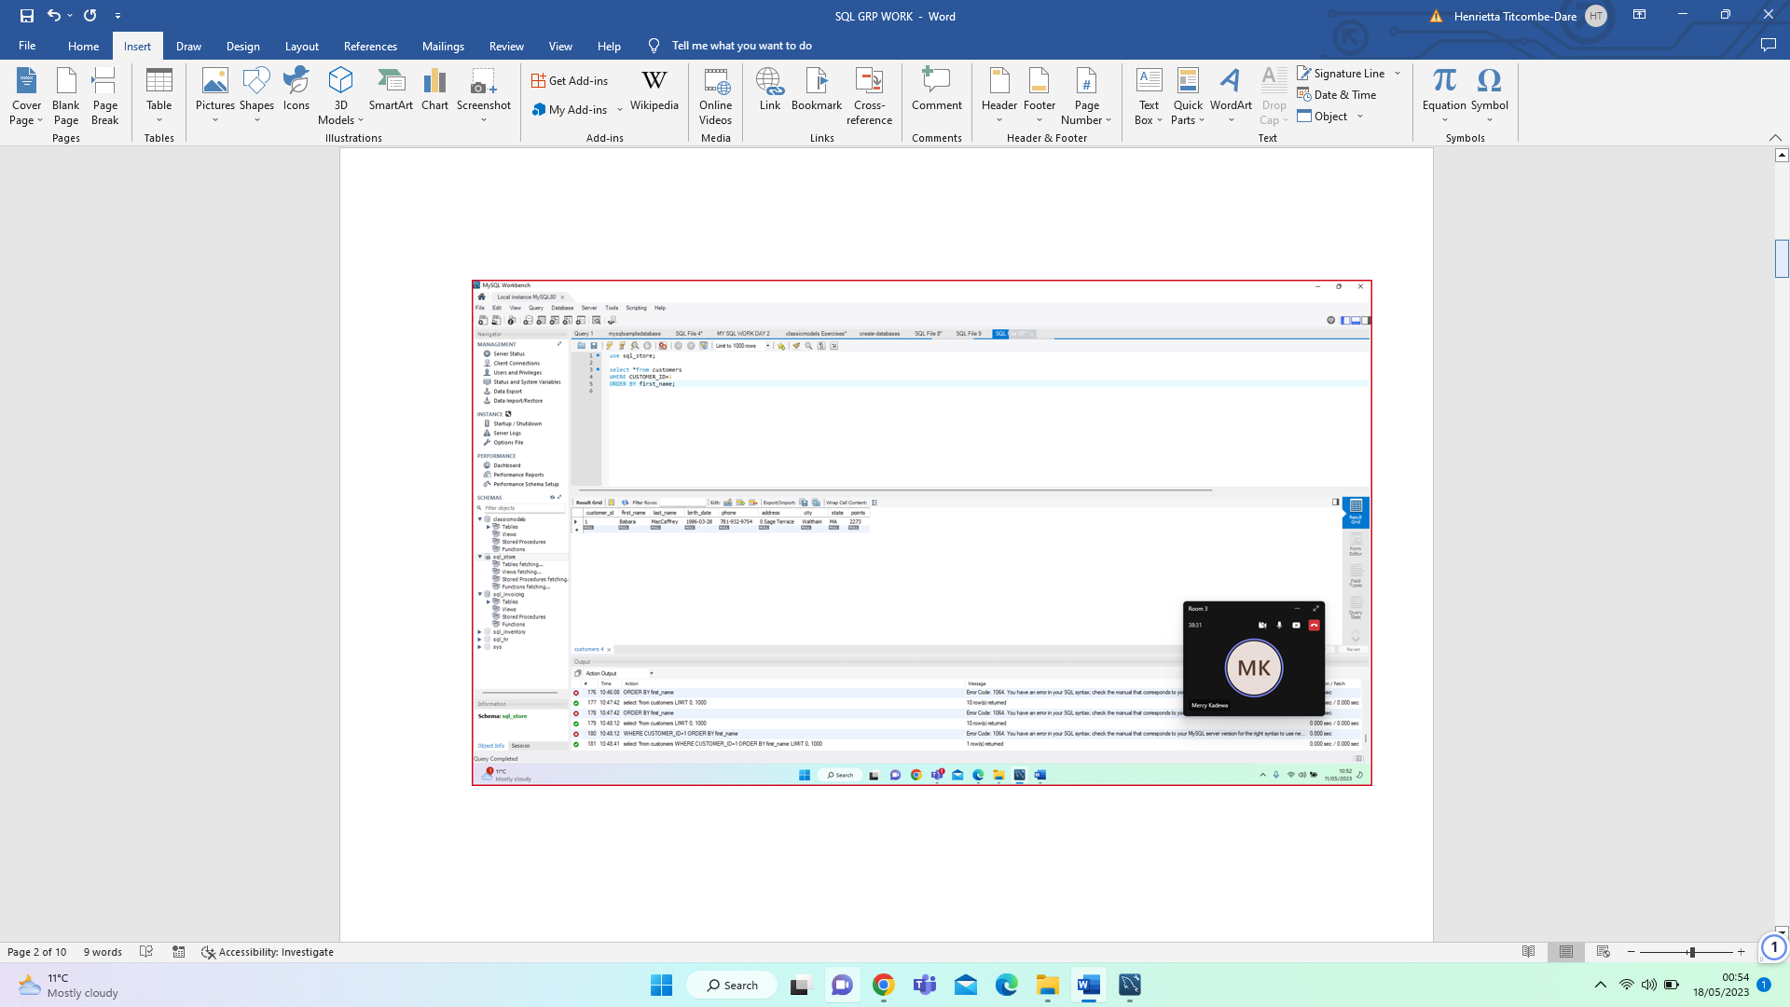

FILTERING AND SORTING USING WHERE AND ORDER BY/ QUERY 2 -SELECT LAST NAME, FIRST NAME, POINTS, POINTS+10 FROM CUSTOMERS

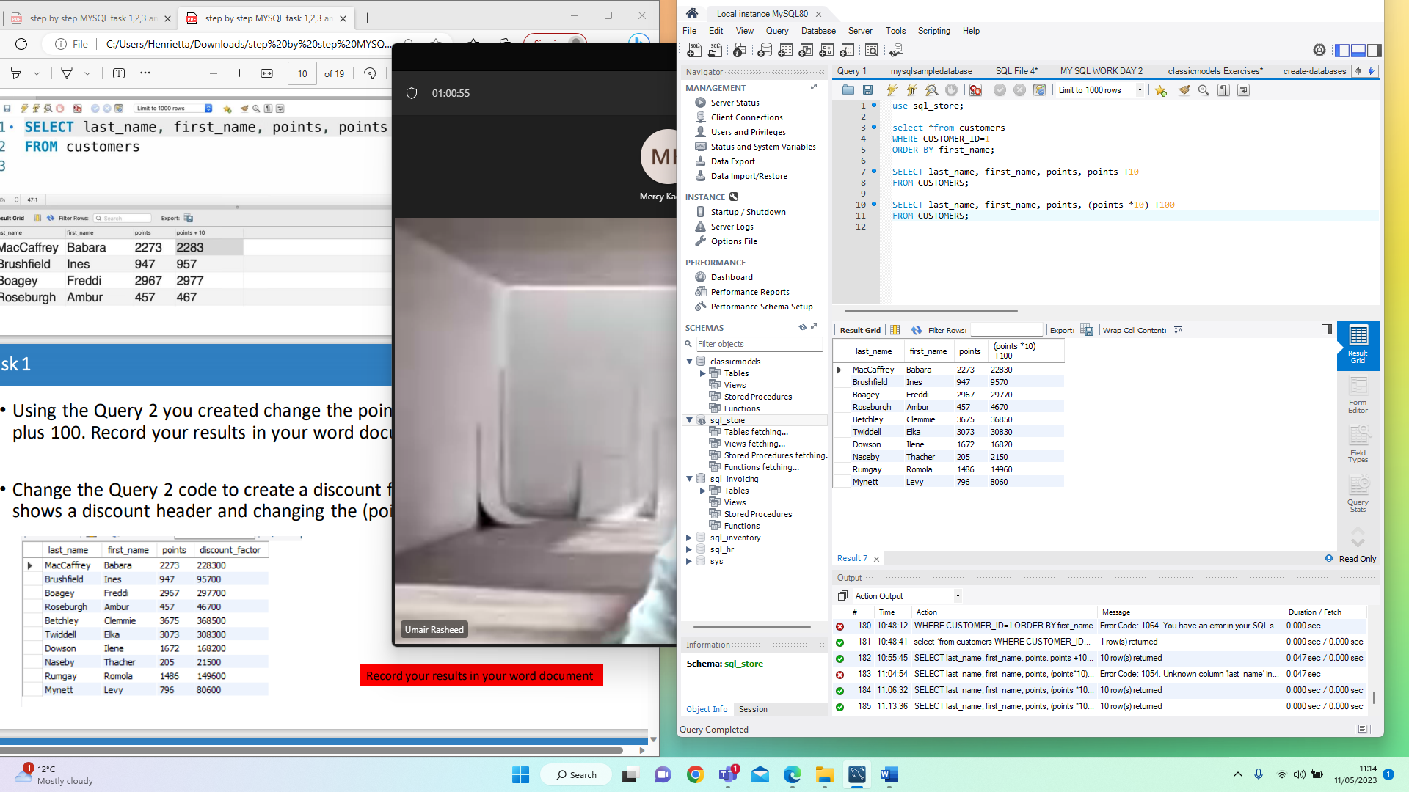

TASK 1 – CREATE A CHANGE POINT SHOWING THE DISCOUNT FACTOR

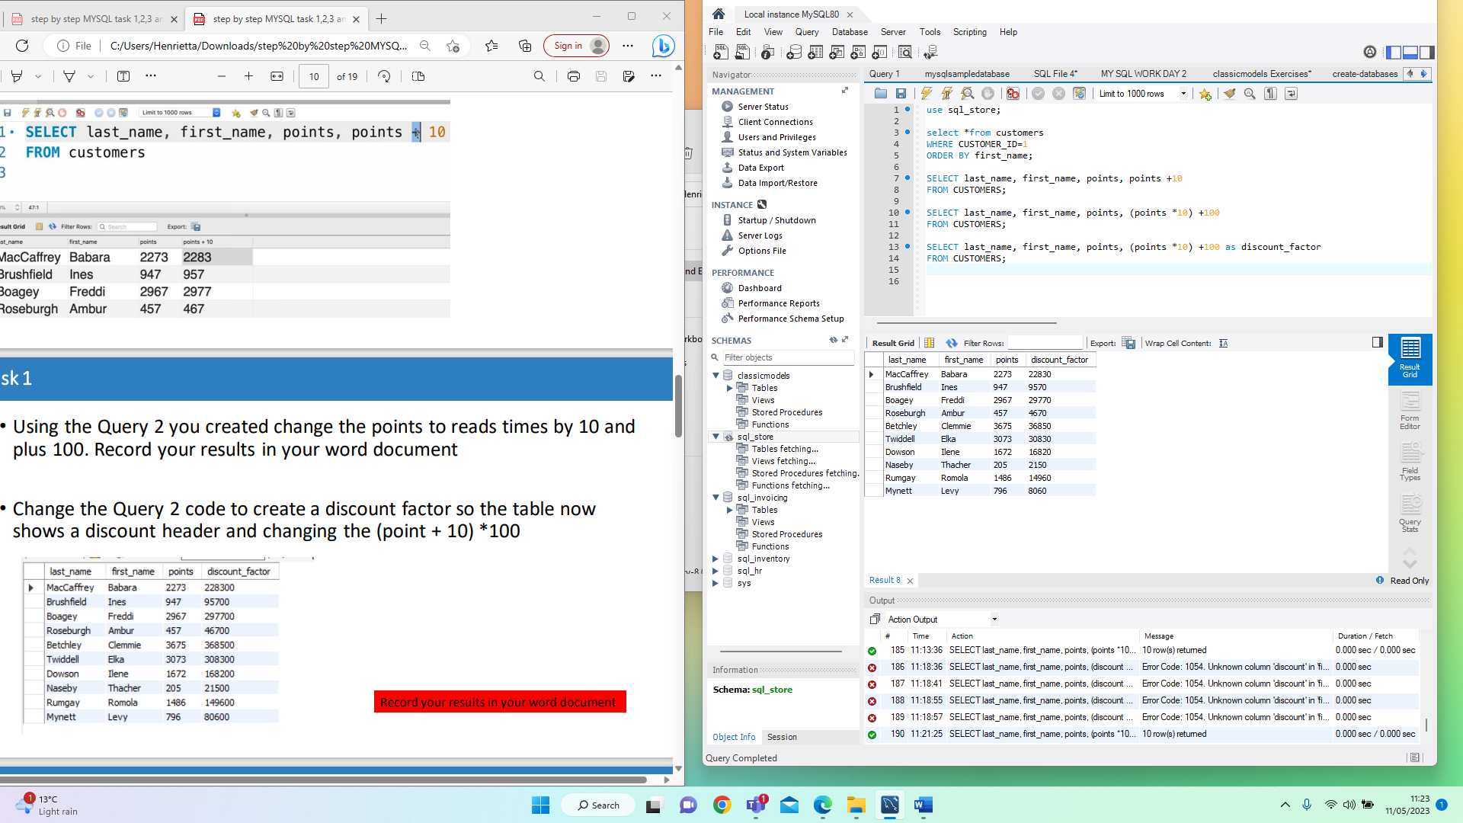

TASK 2– QUERY SHOWING NAME, UNIT PRICE AND NEW PRICE

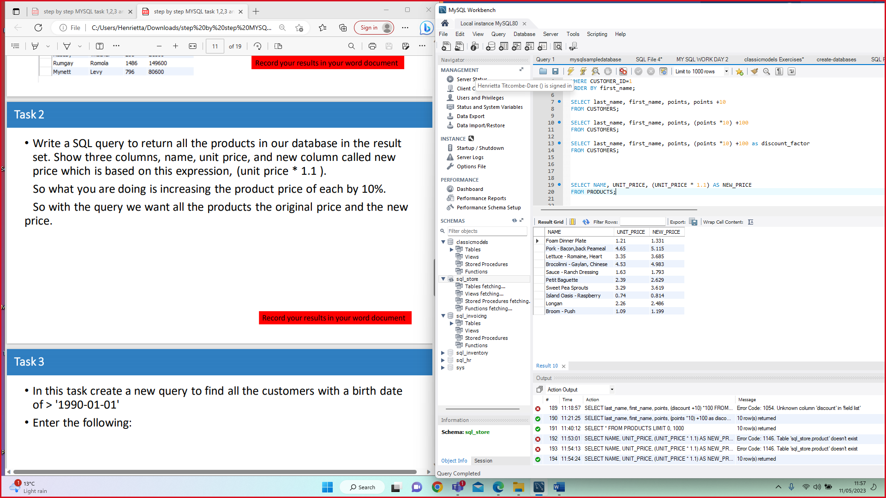

TASK 3 – New query to find all customers with birthdate of >1990-01-01

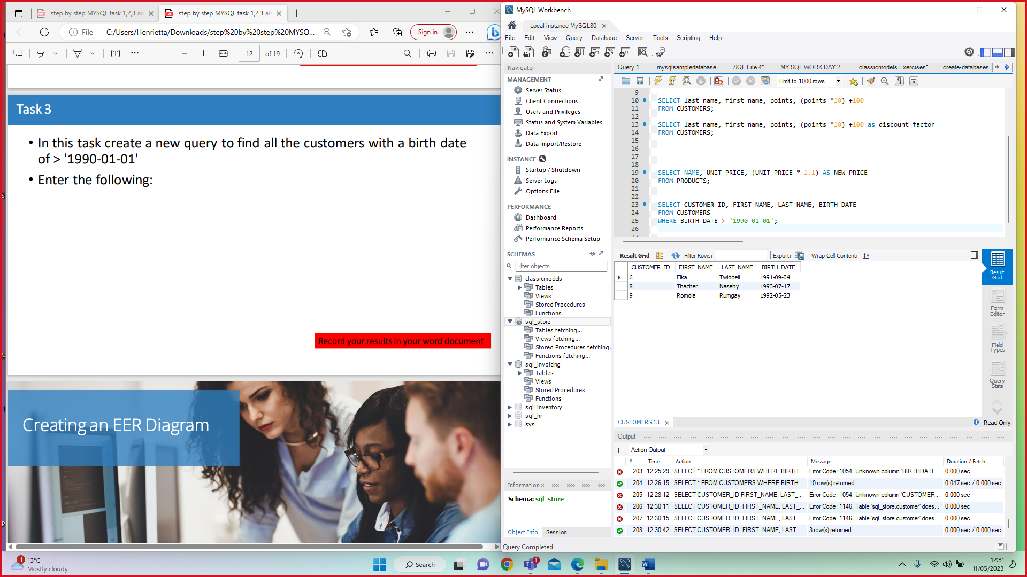

**Creating an EER Diagram (Enhanced Entity-Relationship)**

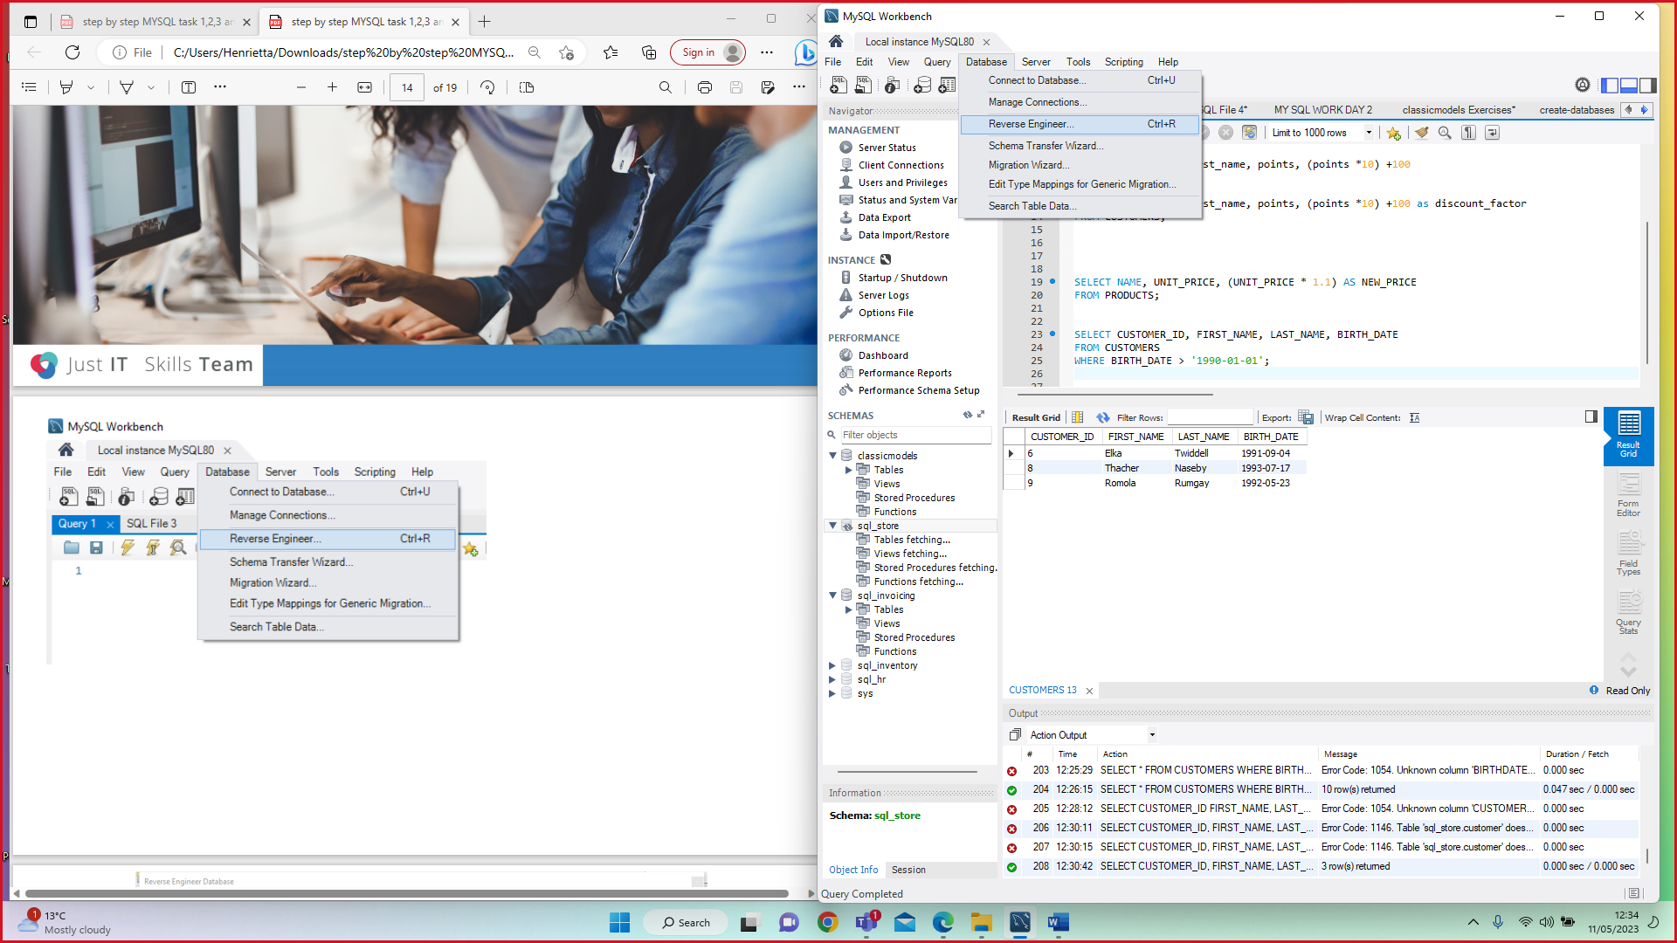

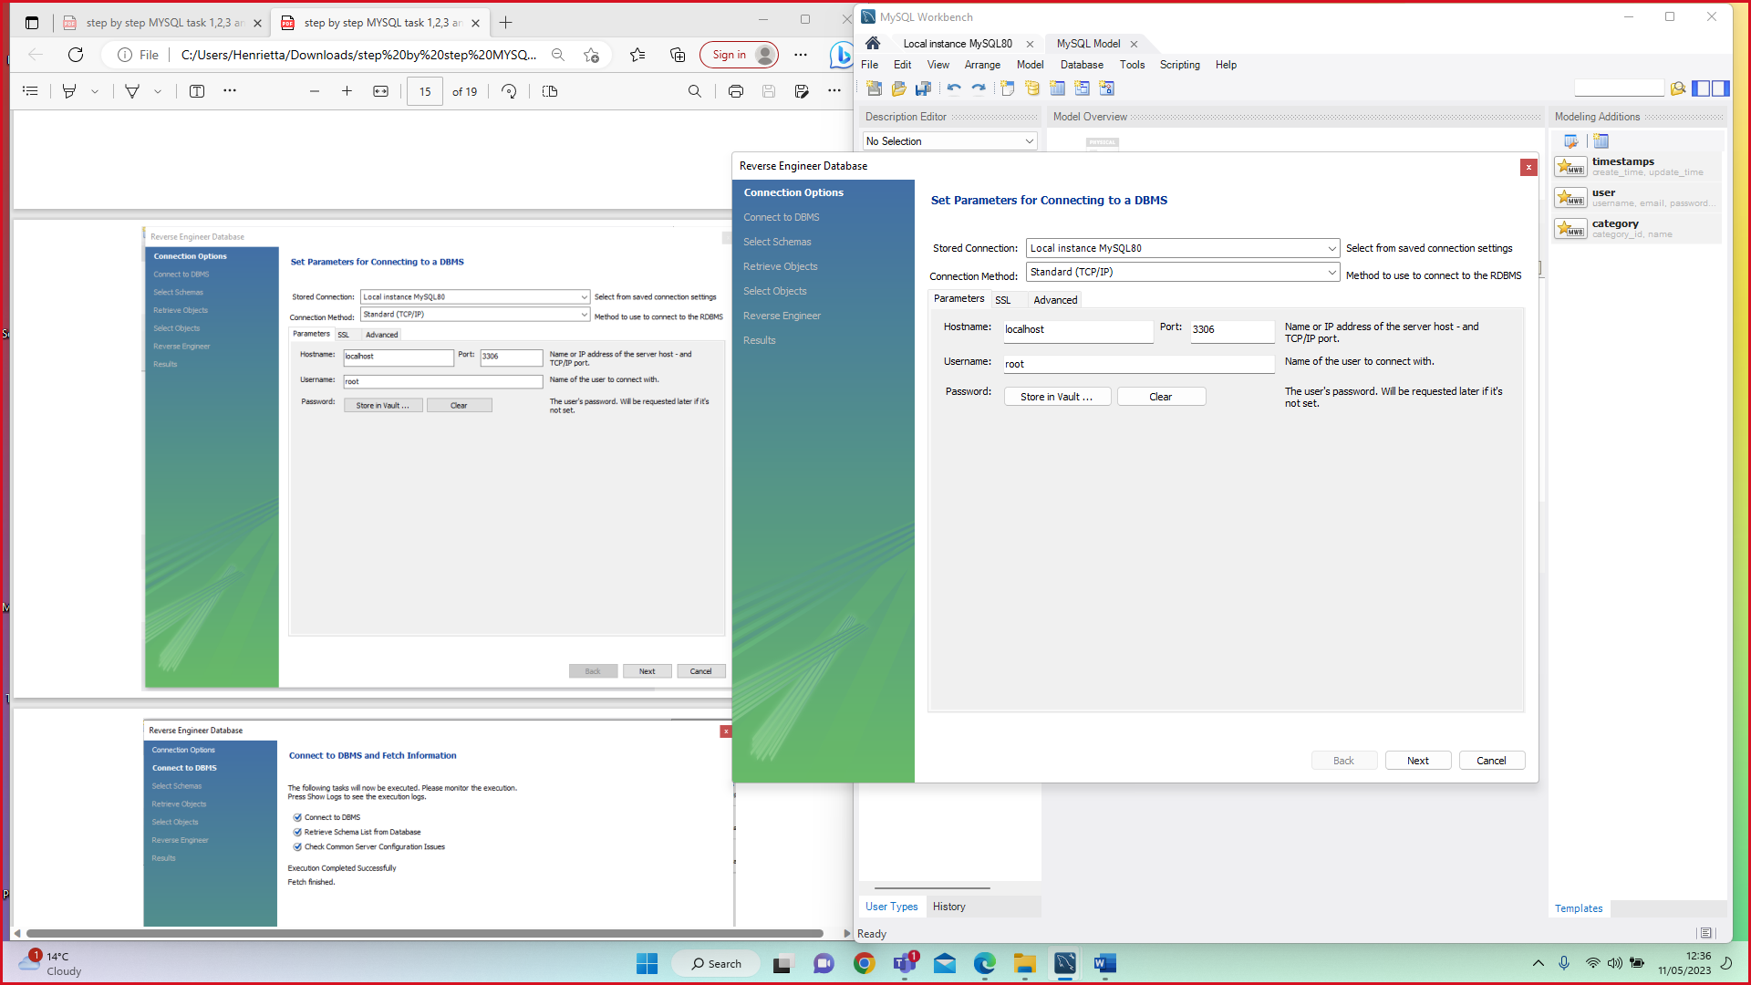

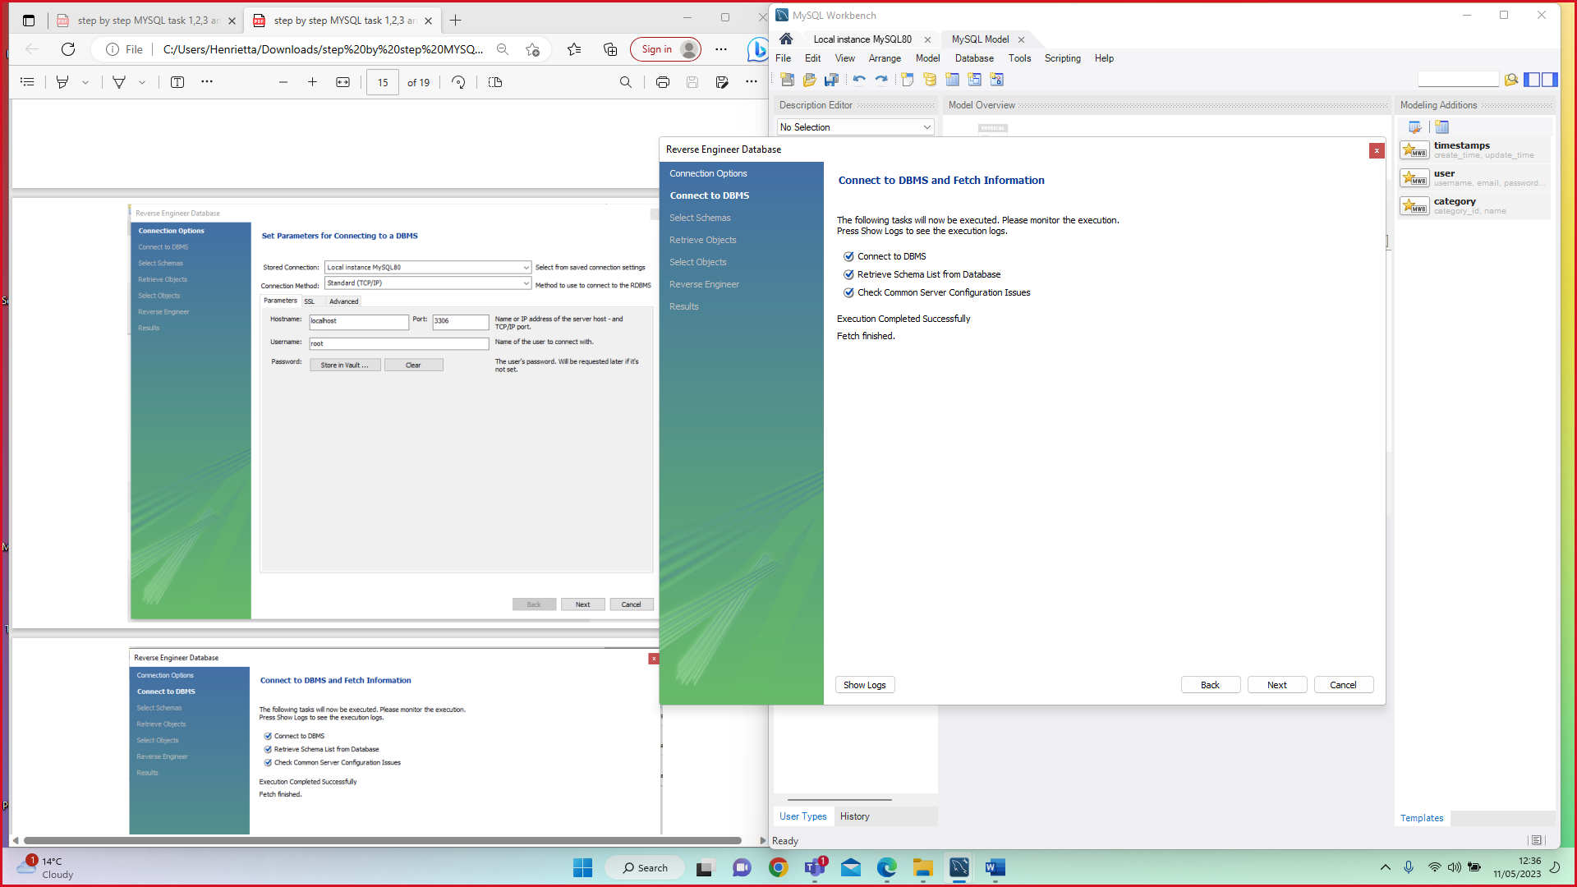

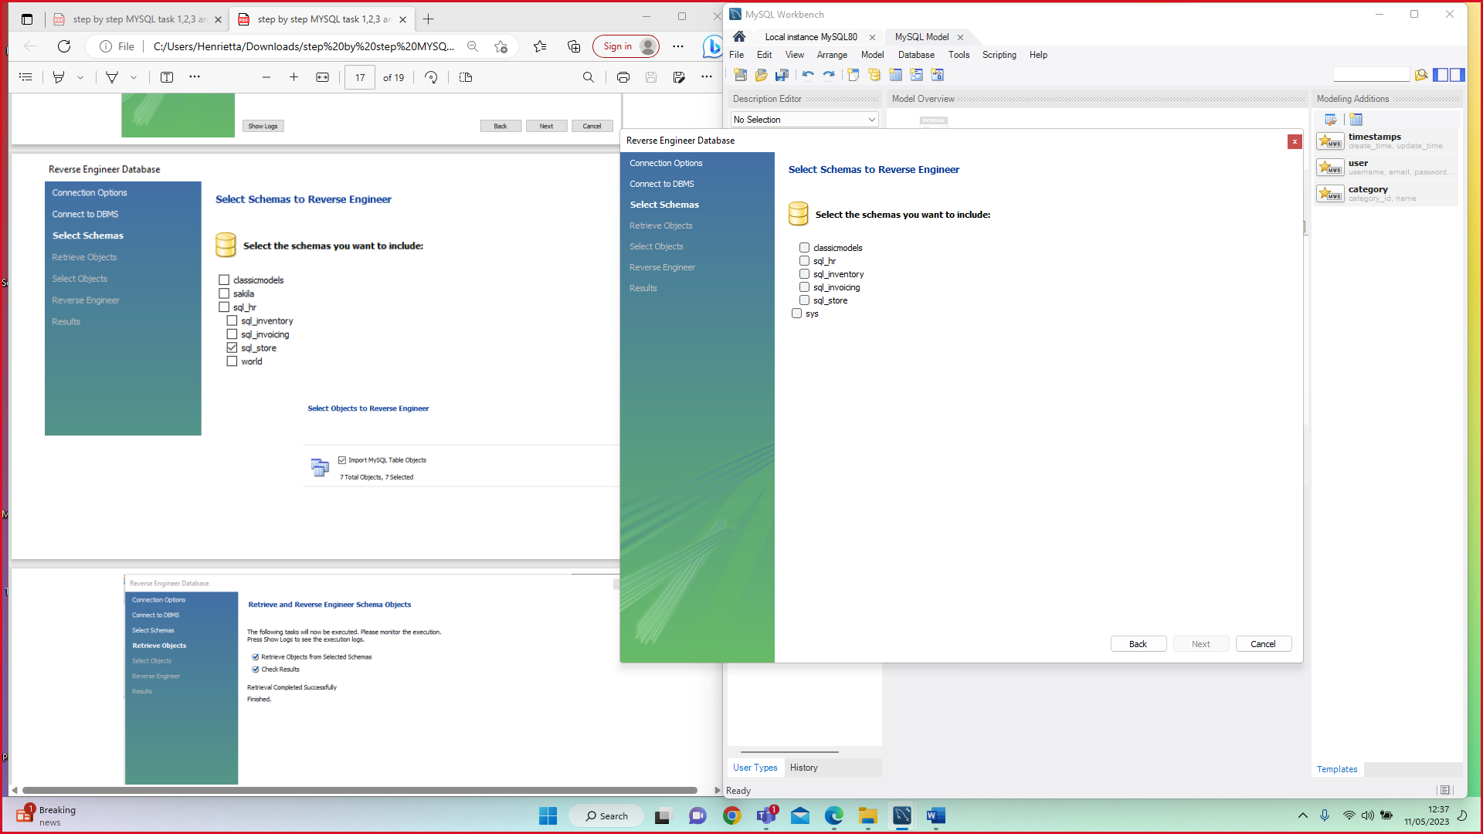

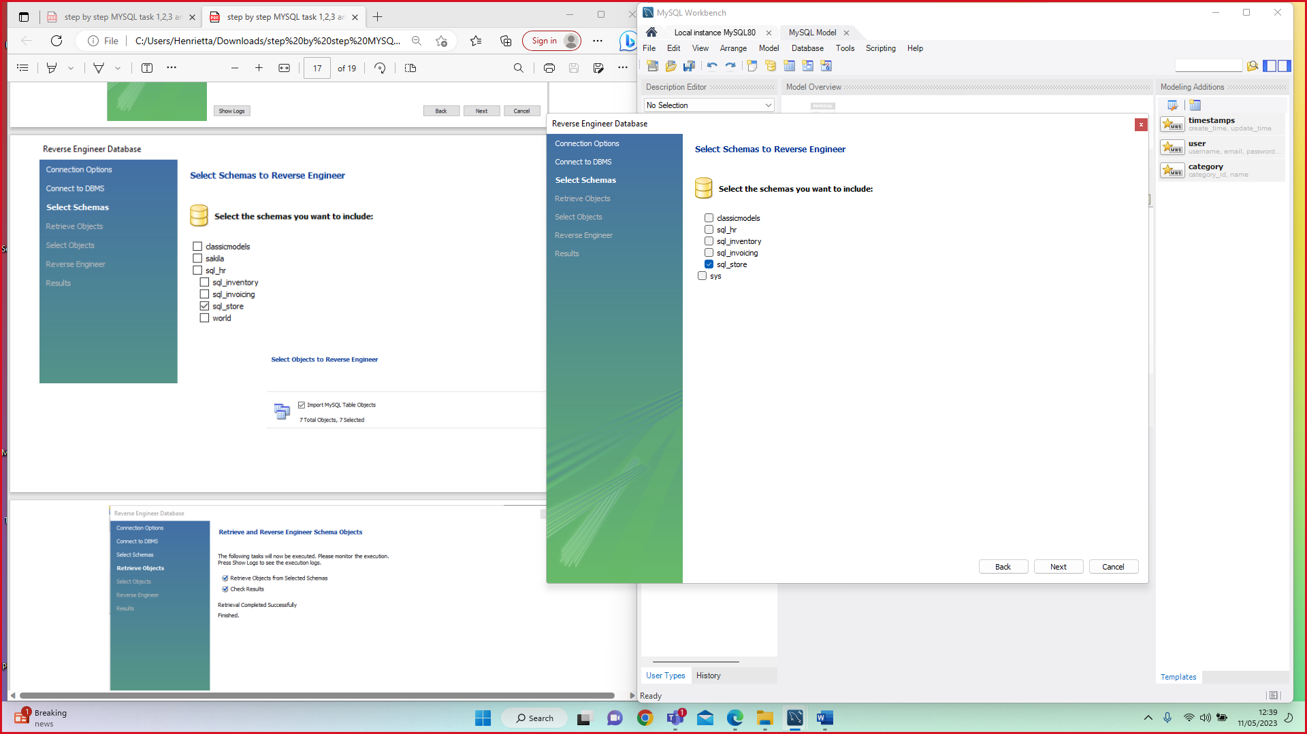

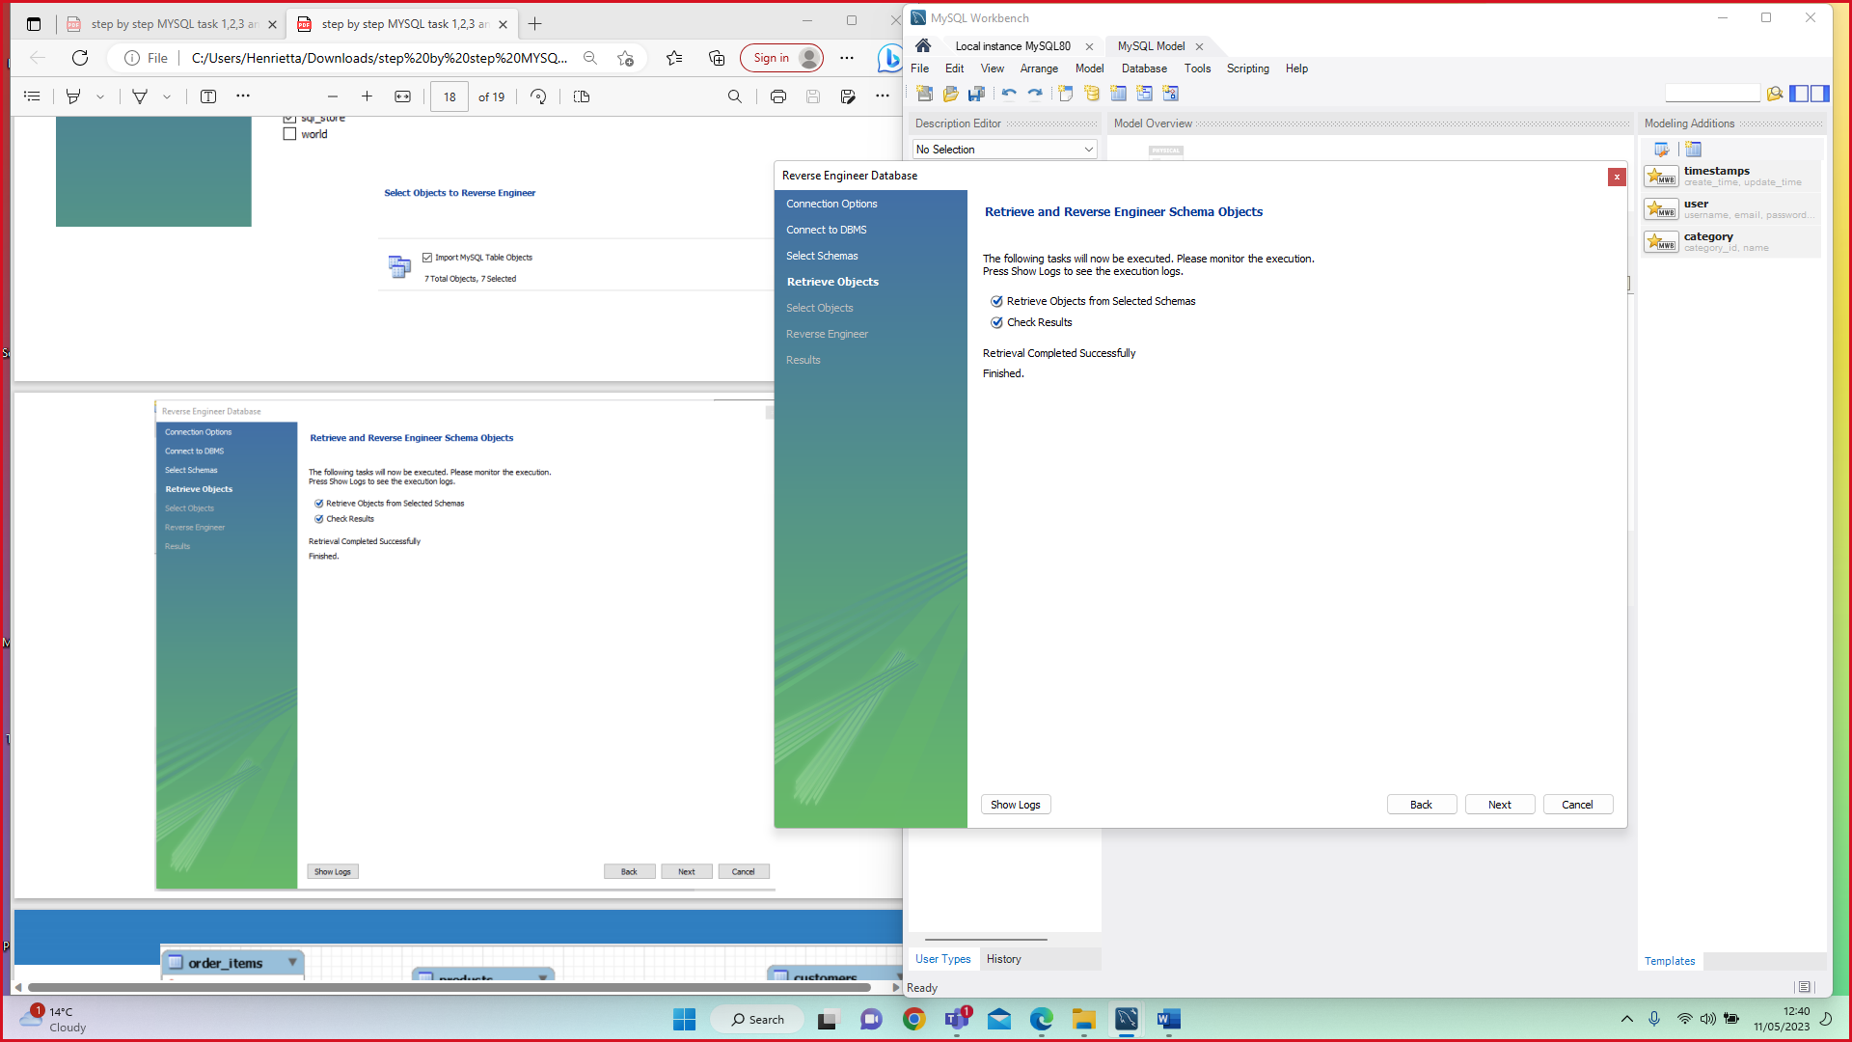

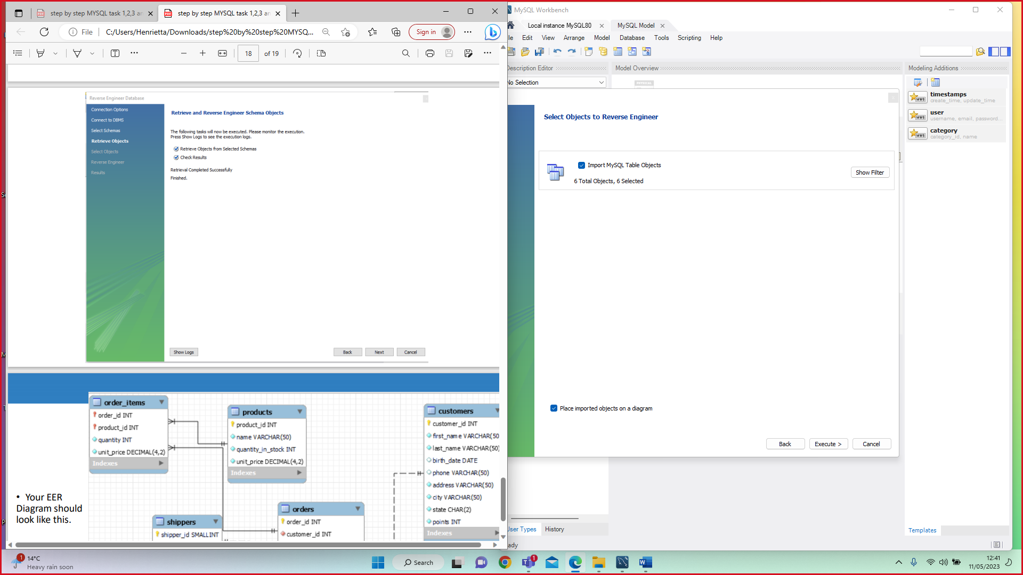

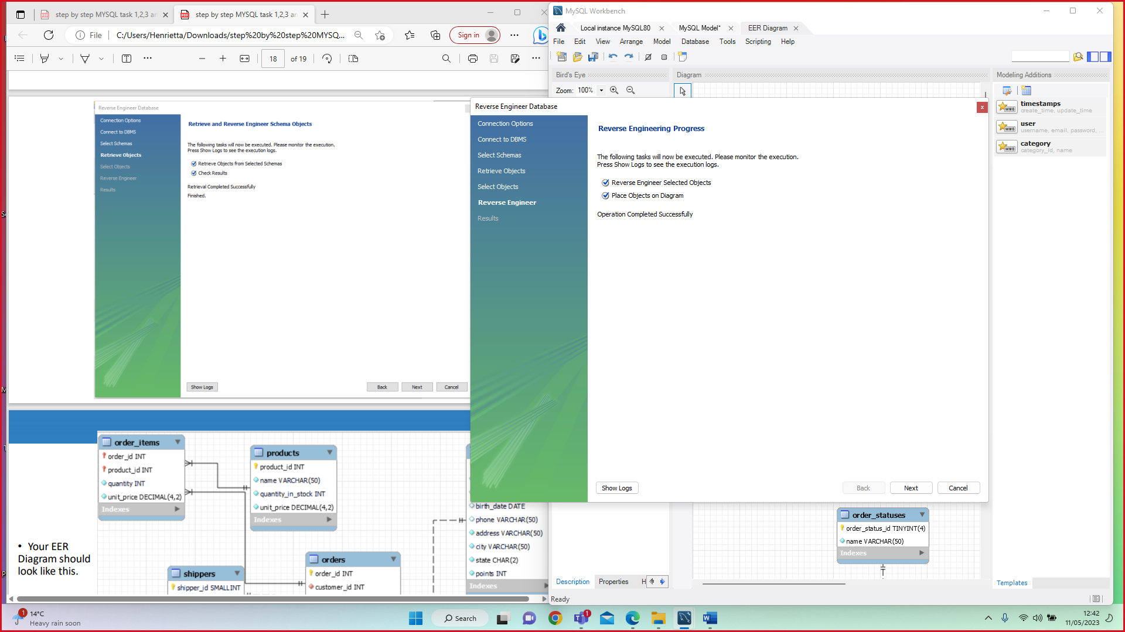

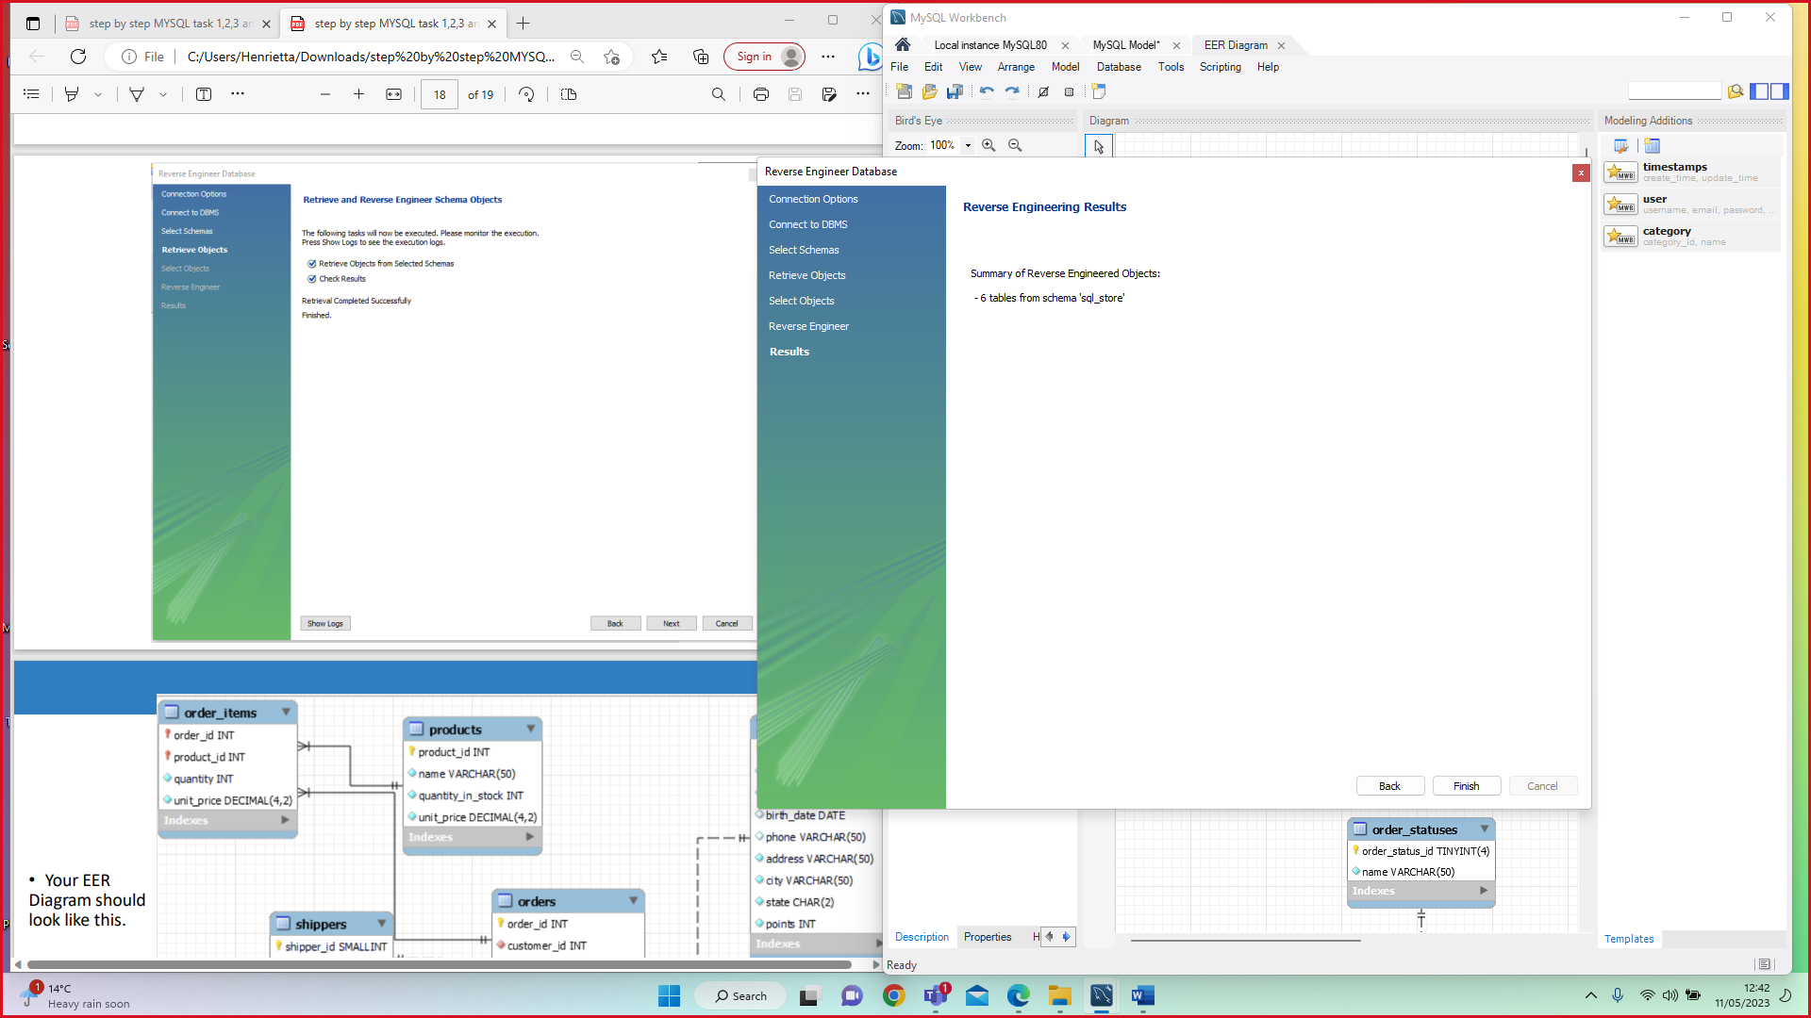

**EER (ENHANCED ENTITY- RELATIONSHIP) DIAGRAM OUTCOME**

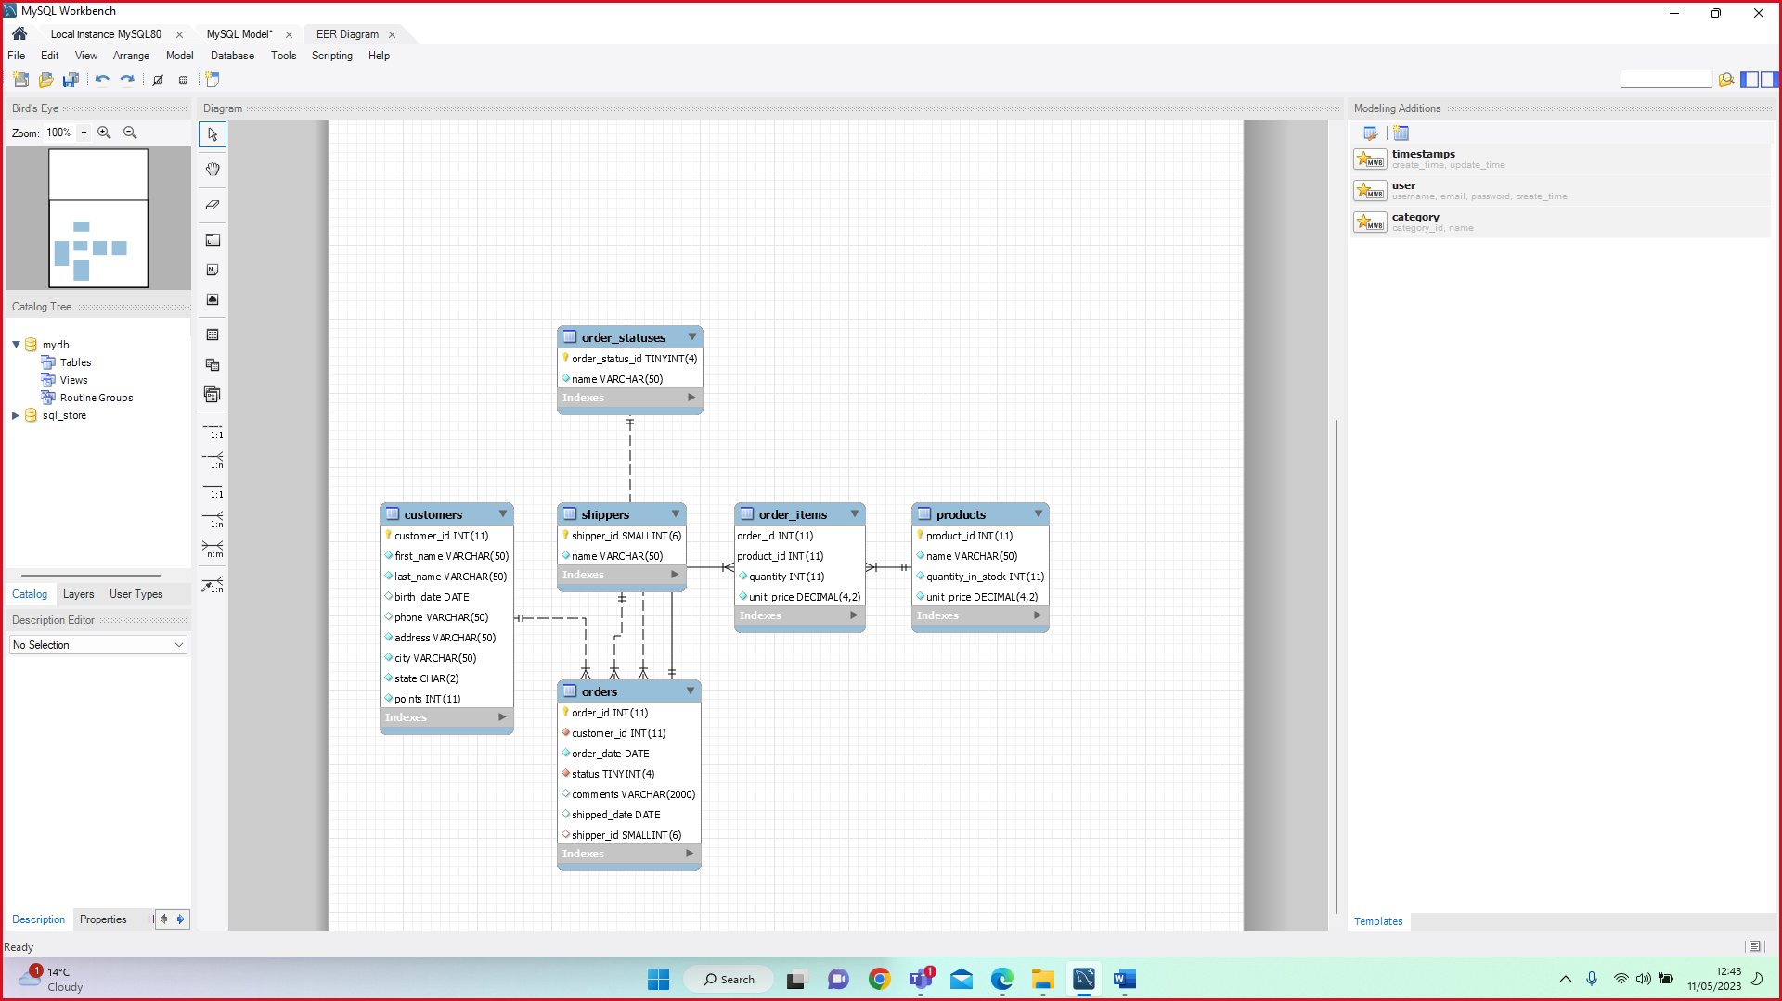

**MY OWN QUERY**

FINDING CUSTOMERS BIRTHDATE >1991-02-03

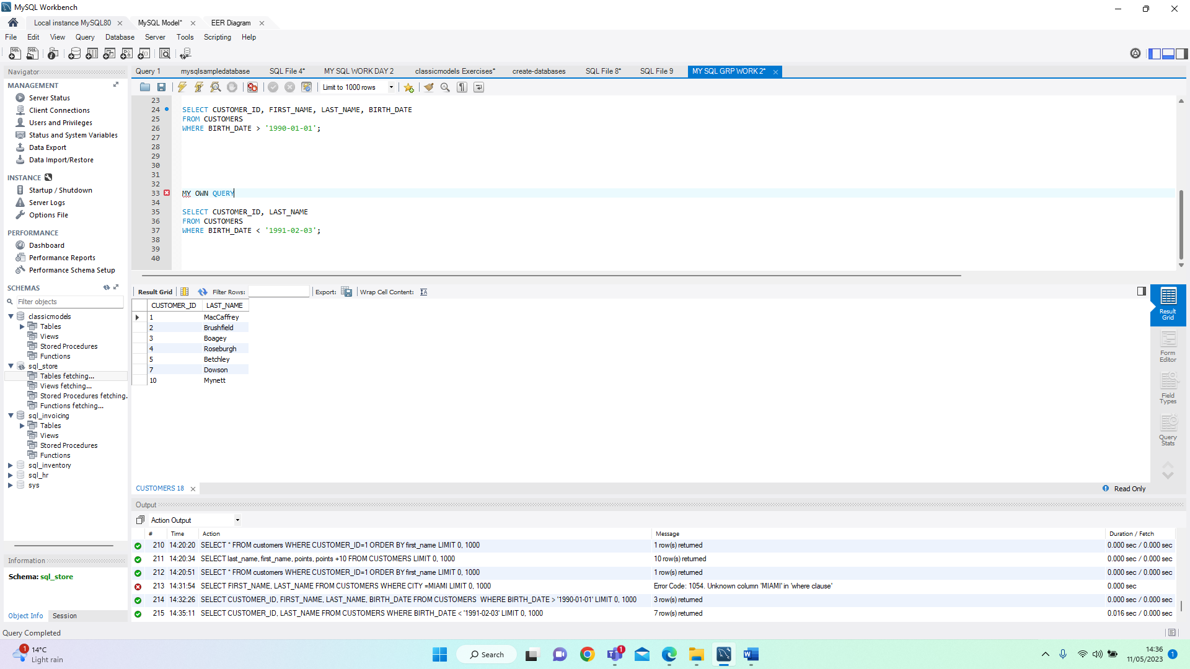

THANK YOU FOR LISTENING

HENRIETTA TITCOMBE-DARE

07507642011